Hysteresis PPO-Lag
Motivation: PPO-Lag uses a Lagrange multiplier to balance reward and cost. However, the standard update reacts to every small cost change near the limit. This can make the penalty fluctuate too much and make training less stable. To address this issue, we propose Hysteresis PPO-Lag, which replaces the standard dual update with a three-region hysteresis rule. The key idea is to introduce a deadband around the cost limit: increase the penalty only when cost clearly violates the limit, keep it unchanged near the boundary, and relax it when cost is safely below the limit, especially when reward is degrading.

Method: HysteresisPPOLag preserves the original PPO actor-critic optimization method while replacing the standard Lagrange multiplier update with a hysteresis-based rule. In standard PPO-Lag, the policy is optimized using a mixed advantage
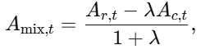
where $A_{r,t}$ and $A_{c,t}$ denote the reward and cost advantages, respectively, and $λ≥0$ is the Lagrange multiplier. The actor is then updated using the PPO clipped objective
where
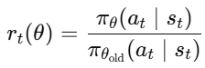
Instead of updating λ by a standard dual ascent step, we define a normalized cost error
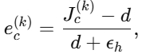
and a reward trend term
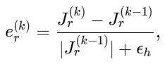
where ${J_{c}}^{(k)}$​ and ${J_{r}}^{(k)}$​ are the mean episode cost and return at epoch $k$, and $d$ is the cost limit. The multiplier is then updated by a three-region hysteresis rule:
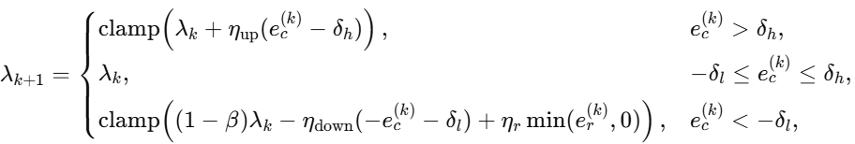
where
This design introduces a deadband around the cost limit. The penalty increases only when the cost clearly exceeds the constraint, remains unchanged when the cost is close to the boundary, and decreases when the policy is safely below the limit. Also, if the policy is already safe but the reward starts to decrease, the reward-aware term further reduces λ. This prevents the penalty from staying too strong and gives the policy more room to improve the reward. In implementation, λ is updated once per epoch before the PPO update, and the method directly bypasses the default PPO-Lag multiplier update so that only the hysteresis rule determines the penalty used in policy optimization.

Environment: We evaluate HysteresisPPOLag on two standard safe RL environments, SafetySwimmerVelocity-v1 and SafetyPointGoal1-v0, using 5 random seeds. Each run uses 4M total environment steps with 20k steps per epoch. The cost limit is set to 25. Actor and critic networks both use two hidden layers of size 256. The hysteresis controller uses symmetric upper and lower thresholds of 0.05, with separate gains for penalty increase, relaxation, and reward-aware relaxation.

Results: The hysteresis PPO-Lag is compared against the PPO-Lag (baseline)
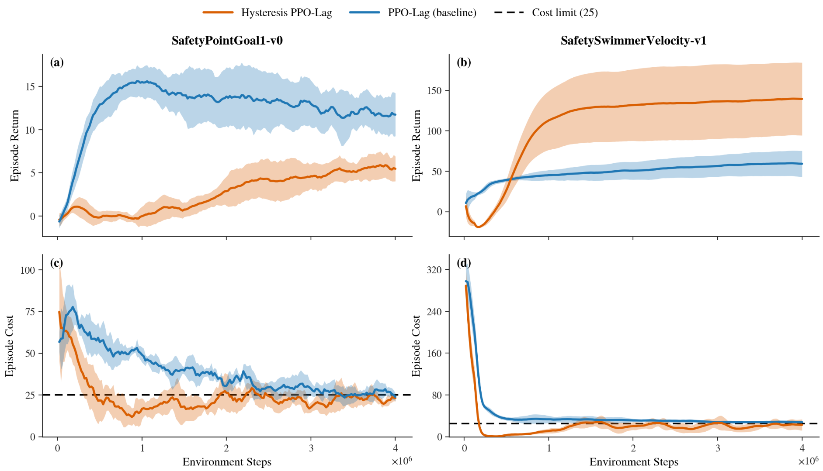
In both environments, the proposed method reduces cost more aggressively and reaches the cost limit more quickly. On SafetyPointGoal1-v0, hysteresis PPO-Lag drives the cost below the cost limit much earlier than the baseline and keeps it near or below the limit for most of the training. However, this stronger constraint satisfaction is accompanied by lower episode return, indicating a more conservative policy. In contrast, on SafetySwimmerVelocity-v1, the proposed method achieves both lower cost and higher return than PPO-Lag. These results suggest that the hysteresis-based multiplier update improves safety performance, while its effect on reward depends on the environment. This means the hysteresis buffer zone can prevent the penalty from changing too often and help reduce cost violations faster. However, in some environments, it may keep the penalty too high, which can lower the final reward. Moreover, hysteresis PPO-Lag has a larger standard deviation in reward in SafetySwimmerVelocity-v1. This is mainly due to a single seed that stopped improving early and converged to a low-reward solution. This may happen because the proposed hysteresis update can make the penalty too strong early in training for some runs, reducing exploration and leading to a safer but more conservative policy.

